**PROJECT REPORT**

1. **INTRODUCTION**
   1. Overview

Vehicle Management is an application where a customer Details are stored inorder to choose cars, bikes and commercial vehicles for travel with in the city. The data which is stored here is further used to remind them if any offers are provided during the seasons and any updates regarding vehicles are sent to them in the form of messages and mails.

* 1. Purpose

The Vehicle Management System (VMS) is an application for the Automotive industry. It su pports, in the area of Sales & Services, the business processes that you require as vehicle importer when dealing with your original equipment manufacturers (OEMs) and your dealers in new and used vehicle sales.

Develop a comprehensive vehicle management system that can be customized to the needs of any organization.

Implement a user-friendly interface that allows users to access and manage vehicle data from any device.

Integrate the system with other relevant applications such as accounting and inventory management systems.

Provide real-time analytics and reporting features to help organizations make data-driven decisions about their fleet management.

**2. Problem Definition & Design Thinking**

2.1 Empathy Map

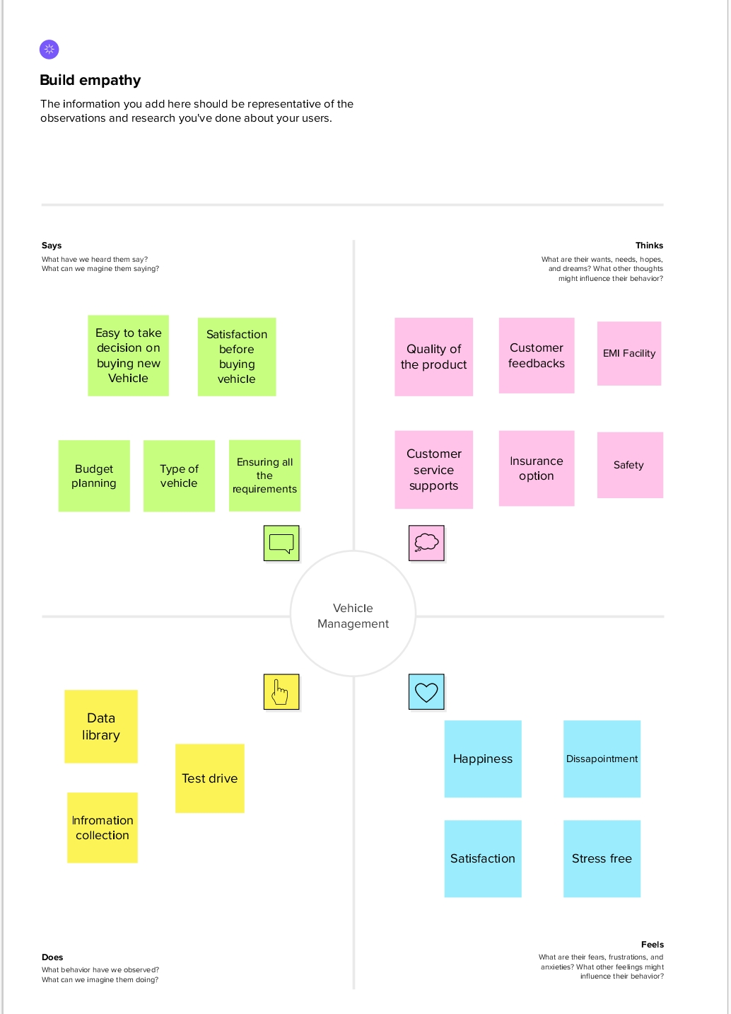-

2.2 Ideation & Brainstroming

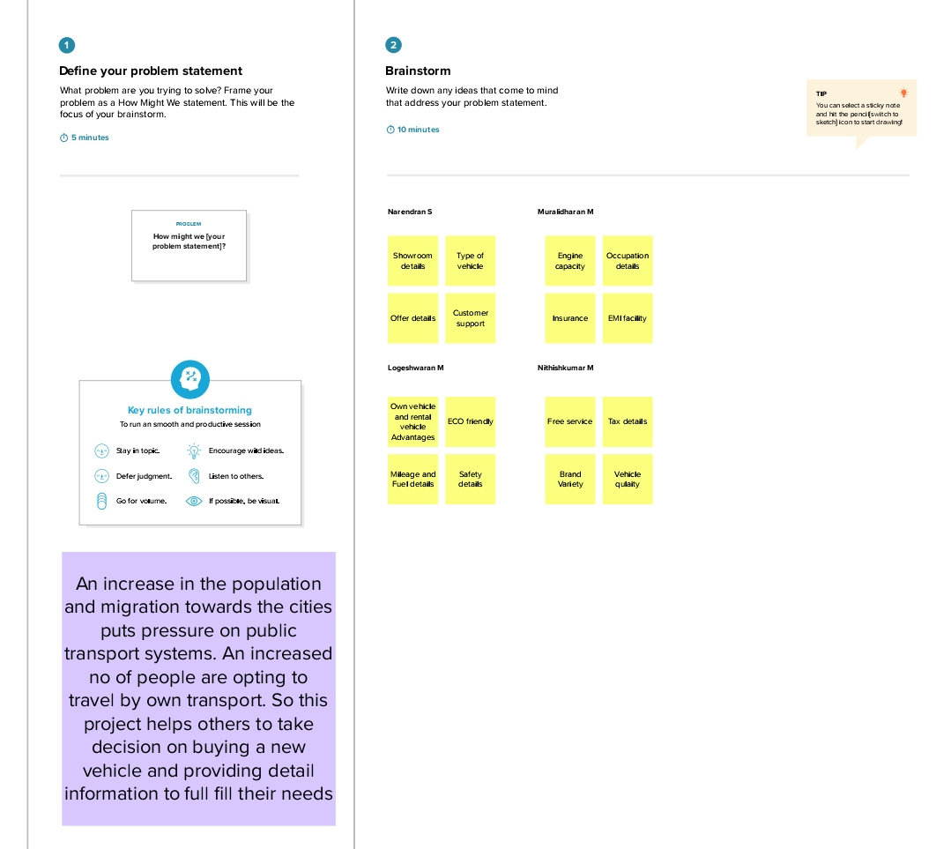

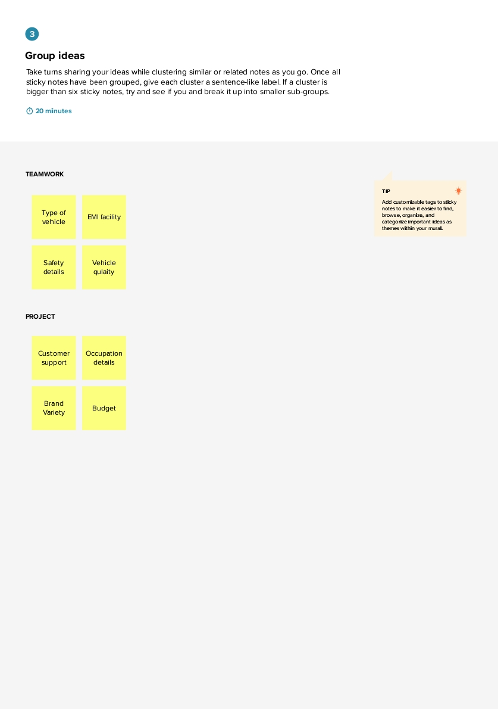

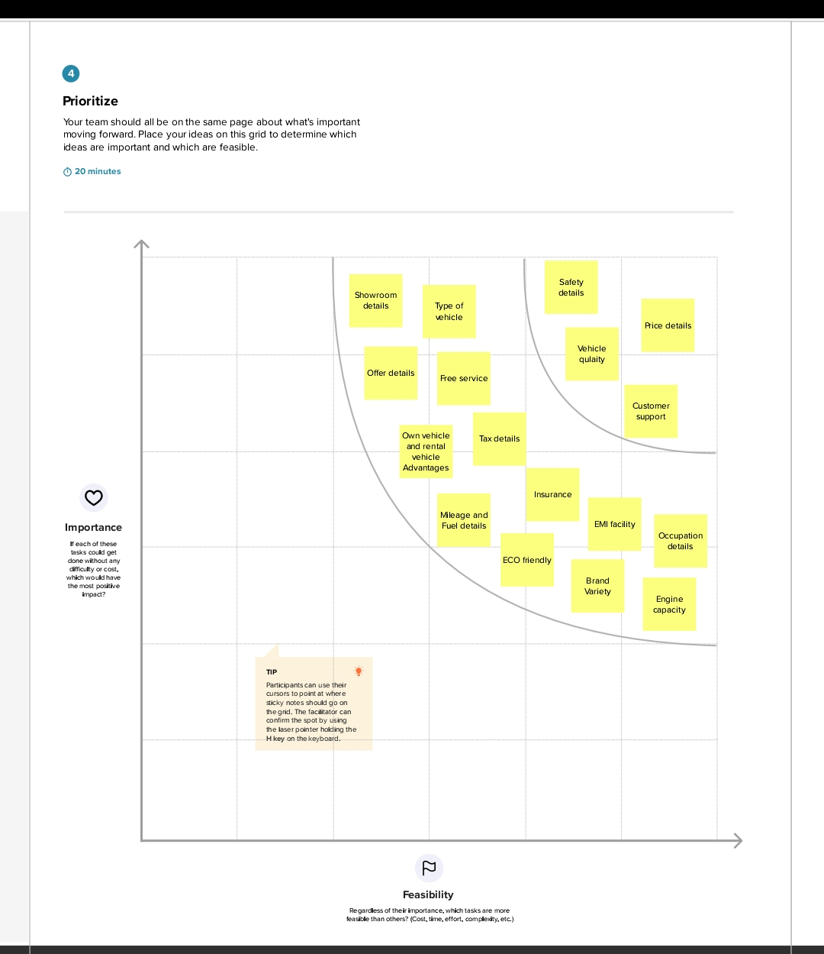

1. **RESULT**

|  |  |
| --- | --- |
| **Object name** | **Fields in the Object** |
| Vehicle | |  |  | | --- | --- | | Field label | Data type | | Customer Name | Text | | Customer Mobile No | Number | | Vehicle Type | Picklist | | 2Wheelers | Picklist | | 4Wheelers | Picklist | | Vehicle Name | Text | | Vehicle No | Text | | Chassic No | Text | | Colour | Text | | Body Type | Text | | Vehicle Includes | Text | | Condition | Picklist | | Seats | Number | | Start Date | Date\ Time | | End Date | Date\ Time | | Milage | Text | | Opportunity | Lookup | |
| Driver | |  |  | | --- | --- | | Driver Name | Text | | Licnence No | Text | | Mobile No | Number | | Fair Per Hour | Text | | Vehicle | Lookup | |

3.2 Activity & Screenshot

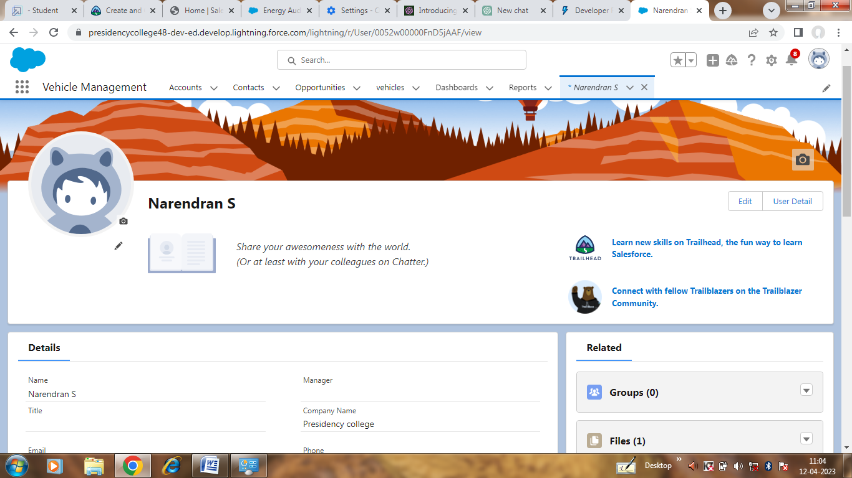Creating Developer Account

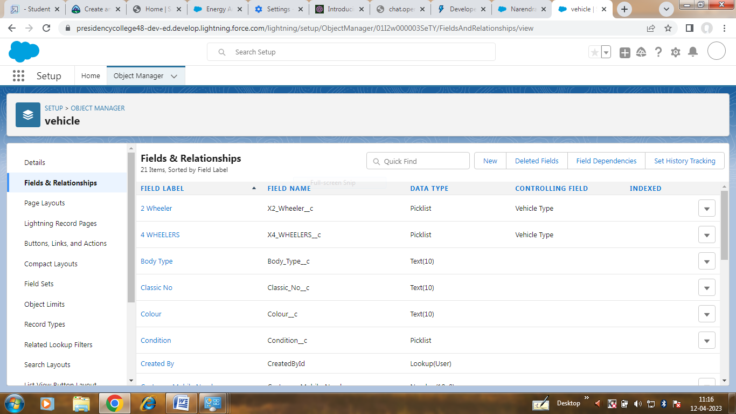

Creation of Objects for Vehicle Management for this Vehicles and Fields and Relationship

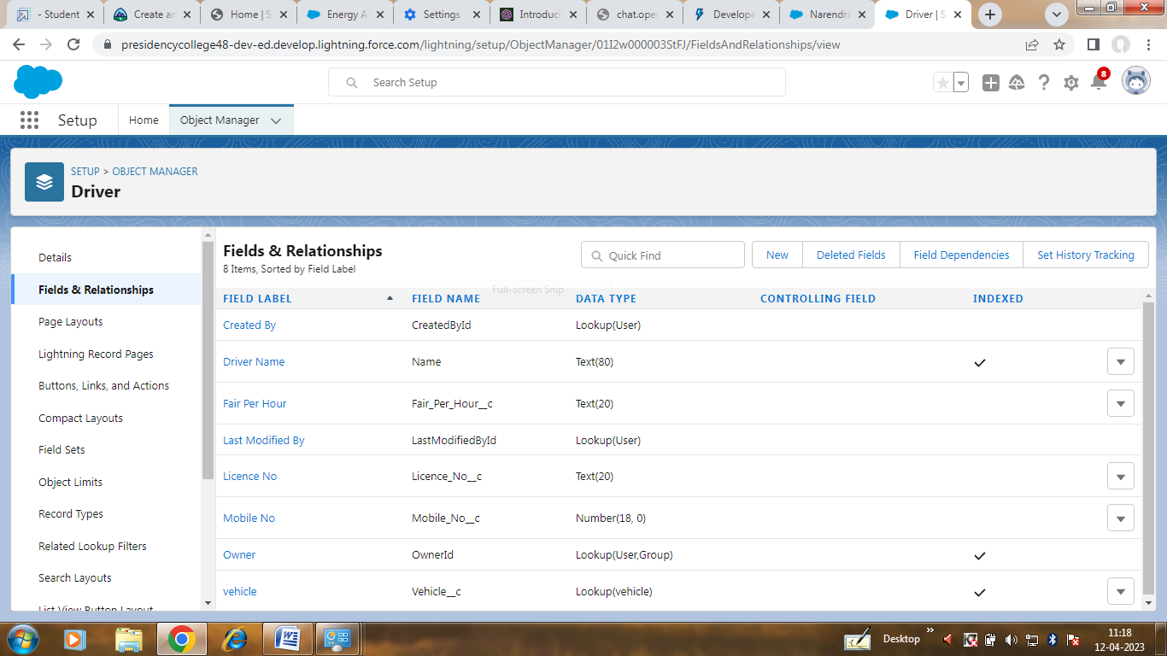Creation of objects for Vehicle Management of Driver and Fields & Rlationship

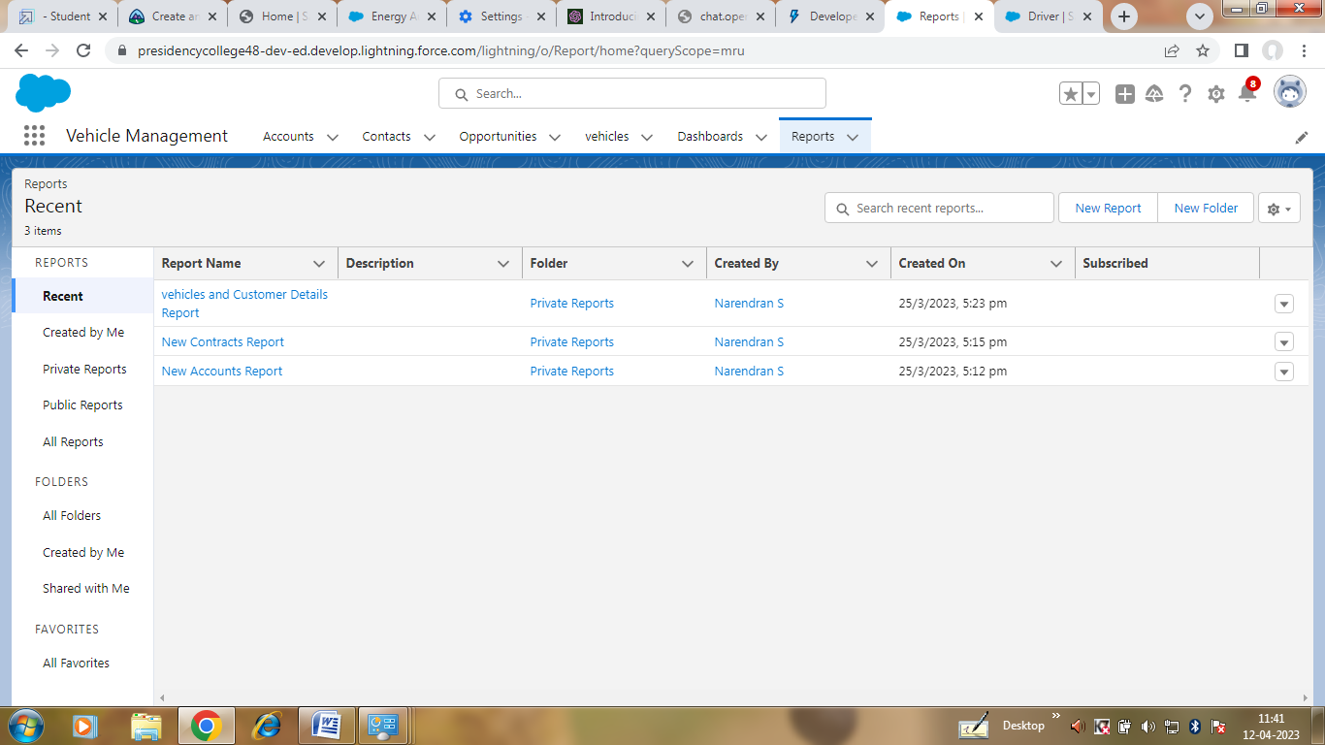

Create the Vehicle Management Construction app

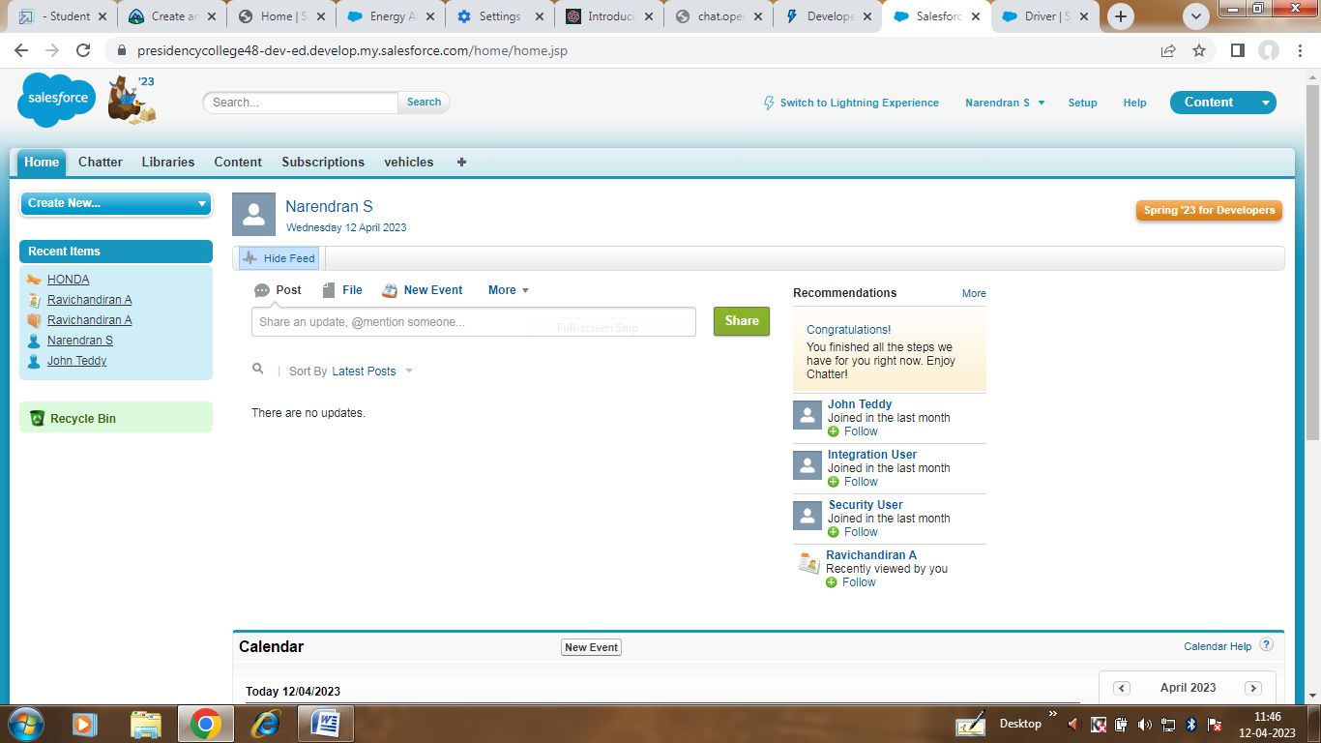

Creating user and Profiles

4 Trailhead Profile Public URl

Team Lead - <https://trailblazer.me/id/nares440>

Team Member 1- <https://trailblazer.me/id/loghu97>

Team Member 2- <https://trailblazer.me/id/murali69>

Team Member 3 - <https://trailblazer.me/id/nithi17>

5. ADVANTAGED & DISADVANTAGES

Improved fleet management: Allows organizations to optimize vehicle allocation and scheduling, reduce vehicle downtime, and improve overall fleet efficiency.

Cost savings: Helps organizations reduce fuel consumption, maintenance costs, and insurance premiums, and avoid penalties for missed maintenance tasks or expired registrations.

Increased productivity: Enables drivers and vehicle managers to access vehicle information and perform tasks more efficiently, reducing administrative workload and improving productivity.

Data-driven decision making: Provides real-time analytics and reporting features that allow organizations to make data-driven decisions about their fleet management

6.APPLICATIONS

Fleet management: The system can be used by transportation and logistics companies to manage their fleet of vehicles. They can use the system to track the location of each vehicle, monitor fuel consumption, and schedule maintenance tasks. The system can also be used to optimize vehicle utilization, reduce downtime, and improve overall fleet efficiency.

Government agencies: Government agencies such as police departments, fire departments, and public works departments can use the system to manage their vehicle fleets. They can use the system to track vehicle usage, maintenance schedules, and fuel consumption. The system can also be used to monitor driver behavior and performance, ensuring that vehicles are being used safely and efficiently.

Car rental companies: Car rental companies can use the system to manage their rental fleet. They can use the system to track vehicle availability, schedule maintenance tasks, and monitor vehicle usage. The system can also be used to manage customer information and bookings, ensuring that customers have a seamless experience.

Construction companies: Construction companies can use the system to manage their construction vehicle fleet. They can use the system to track vehicle usage, schedule maintenance tasks, and monitor fuel consumption. The system can also be used to manage driver information and monitor driver behavior, ensuring that vehicles are being used safely and efficiently.

Corporate fleets: Large corporations that have their own vehicle fleets can use the system to manage their vehicles. They can use the system to track vehicle usage, monitor fuel consumption, and schedule maintenance tasks. The system can also be used to manage driver information and monitor driver behavior, ensuring that vehicles are being used safely and efficiently.

7. CONCLUUSION

The Vehicle Management System is a powerful tool for organizations that want to manage their fleet of vehicles efficiently. Built using Salesforce, it provides a customizable and user-friendly interface that allows users to access and manage vehicle data from any device. Its advanced features, such as maintenance scheduling, fuel consumption tracking, and driver management, help organizations optimize their fleet utilization and reduce costs. With real-time analytics and reporting features, the system enables data-driven decision making and helps organizations stay ahead of the competition.

8. FUTURE SCOPE

Artificial Intelligence (AI) and Machine Learning (ML): As AI and ML technologies become more prevalent and powerful, there is a growing opportunity to integrate them into vehicle management systems. For example, AI could be used to predict vehicle maintenance needs or optimize vehicle routes for delivery or service teams.

Internet of Things (IoT) integration: IoT devices such as sensors and GPS trackers are increasingly being used to gather real-time data on vehicle performance and location. Integrating this data with a vehicle management system can provide valuable insights for fleet optimization, maintenance scheduling, and driver safety.

Blockchain integration: The use of blockchain technology in the automotive industry is still in its infancy, but it has the potential to revolutionize vehicle management systems. By providing secure and transparent data sharing and tracking, blockchain could help prevent fraud, improve supply chain management, and streamline administrative processes.

Advanced analytics and reporting: As the amount of data generated by vehicle management systems continues to grow, there is an opportunity to develop more advanced analytics and reporting tools. For example, predictive analytics could be used to forecast maintenance needs, while machine learning algorithms could be used to optimize fuel consumption and reduce emissions.

Integration with other systems: Vehicle management systems are just one part of an organization's overall operations. As such, there is a growing need to integrate vehicle management systems with other systems such as inventory management, accounting, and customer relationship management. This would allow organizations to streamline their operations and gain a more comprehensive view of their overall business performance.

Overall, the future of vehicle management systems using Salesforce is very promising, and we can expect to see continued growth and development in the coming years as new technologies and capabilities emerge.